**\*\*\*\*\*Minting my first NFT on OpenSea by connecting your MetaMask or Trust Wallet\*\*\*\***

1. **Install a Wallet:** If you haven't already, you'll need to install a digital wallet that supports Ethereum. MetaMask and Trust Wallet are popular choices. Set up your wallet and ensure it's funded with enough ETH to cover the minting costs (gas fees).

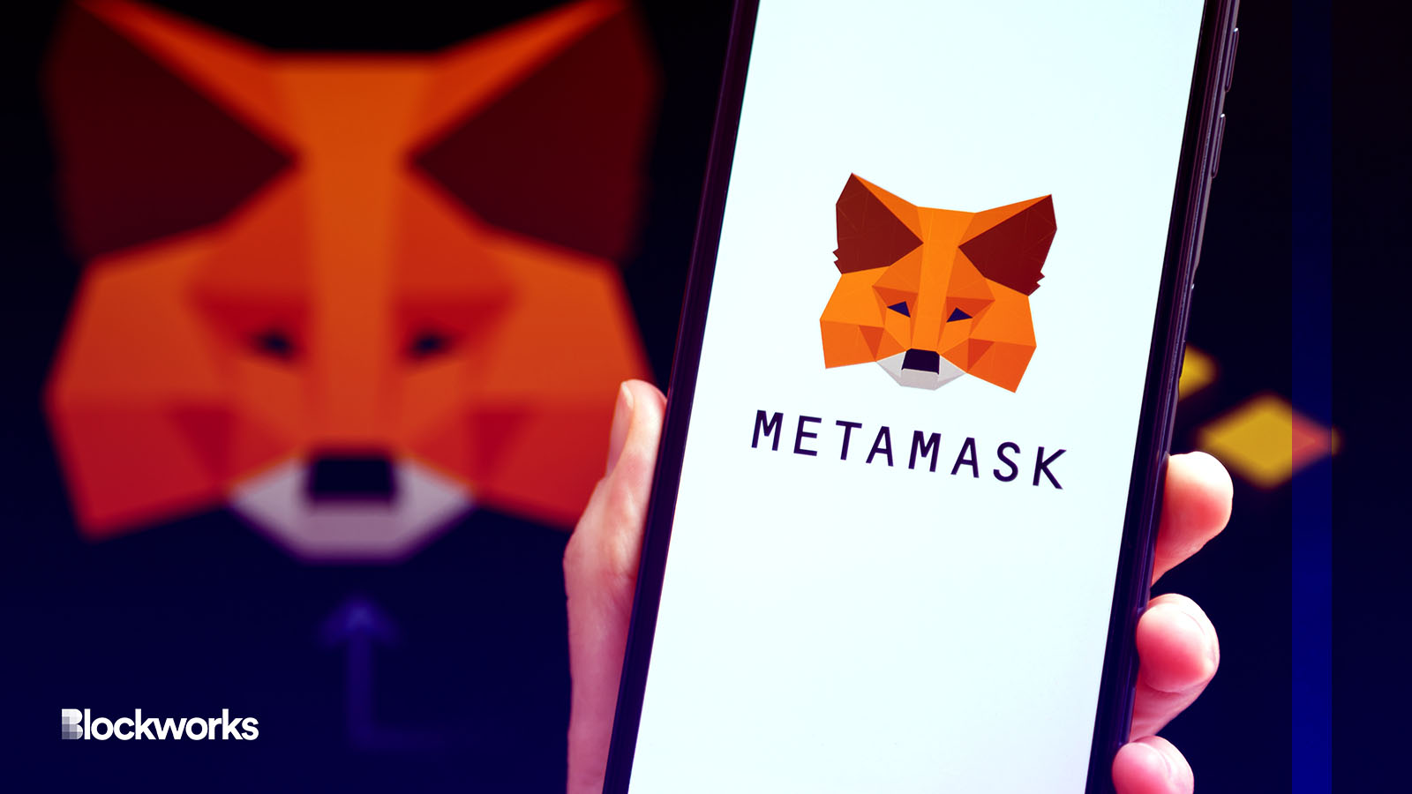

2.**Create Digital Art or Collectible:** You'll need to have a digital item to mint as an NFT. This could be digital art, music, videos, virtual goods, or any digital content you want to tokenize.

3.**Sign Up on OpenSea:** If you're not already a registered user on OpenSea, you'll need to sign up for an account.

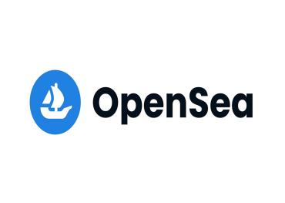

4.**Connect Your Wallet:** Log in to OpenSea and connect your MetaMask or Trust Wallet. This will allow OpenSea to interact with your wallet for minting and managing your NFTs.

5.**Start the Minting Process:**

Click on "Create" or "Mint" on OpenSea's website.

Choose the digital item you want to mint as an NFT.

Fill in the details about your NFT, including its name, description, tags, and attributes.

You may also set up royalties, which determine how much you'll earn from secondary sales of your NFT.

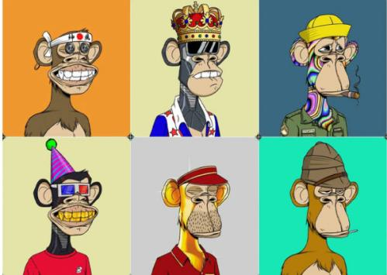

6.**Set Pricing and Properties:**

Choose between an auction-style listing or a fixed-price listing.

Set your initial sale price or reserve price if you're running an auction.

You can also set properties for your NFT, like whether it's a one-of-a-kind item or part of an edition.

7.**Preview and Confirm:** Review all the information you've entered. Make sure everything is accurate, as changes may not be possible after minting.

8.**Mint Your NFT:** Once you're satisfied, click the "Create" or "Mint" button to finalize the process. This will initiate a transaction in your wallet to mint the NFT.

9.**Pay Gas Fees:** Confirm the transaction in your wallet, and be prepared to pay the associated gas fees for the minting process.

1. **Your NFT is Live:** Once the minting is successful and confirmed on the Ethereum blockchain, your NFT will be live on OpenSea and available for sale or auction.

Remember that minting and selling NFTs involve blockchain transactions and gas fees, which can vary depending on network congestion. Ensure you understand these costs and are comfortable with the process before minting your first NFT. Additionally, the NFT space is continually evolving, so it's a good idea to keep up with the latest developments and best practices.

**My opensea account:** <https://opensea.io/Vidyadhari>

